**Divergence Phantoms**

Theres 2 types of divergence,

Type 1, classic higher high but not seeing higher high in the momentum

Type 2, trend following hidden divergence, if you have a higher low but the stochastic cycles down and makes a lower low, thats trend following in nature and gives a good entry for bullish markets

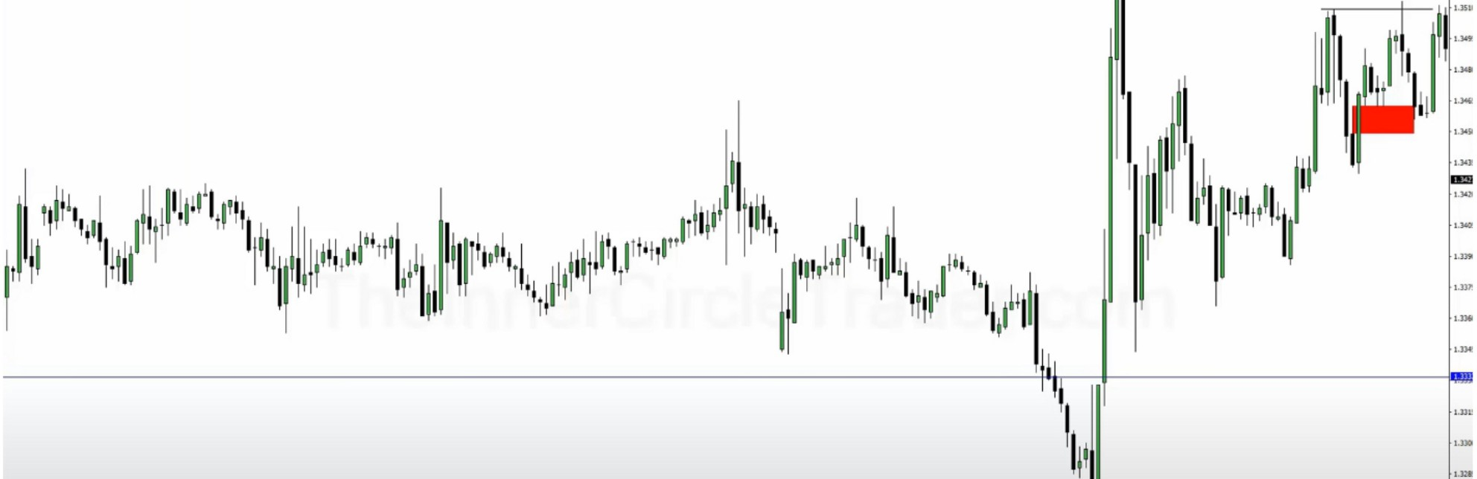

\

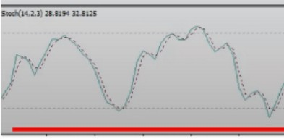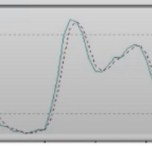

....,

ICT likes to see that happen when we're looking for higher prices, while retail looks at the bearish divergence on the top

Banks are not looking at what indicators are doing, but theyre looking at where the stops are

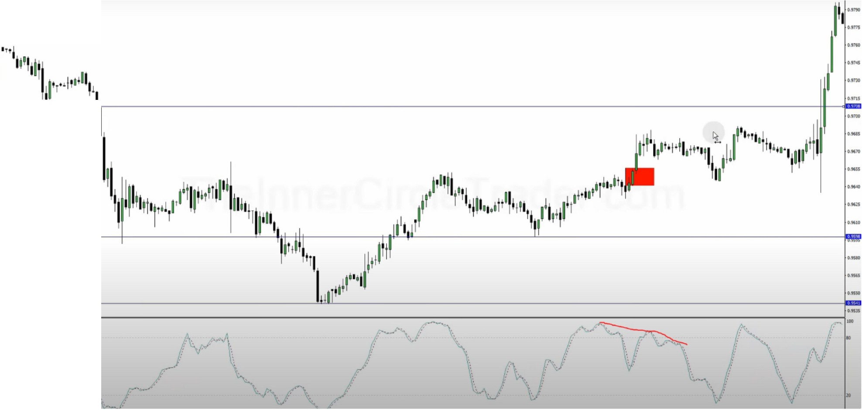

**M,l.J)Ol.lUI.._U.**

Bearish divergence for retail and we expect higher prices still so we buy Do the opposite of retail

Arjo I Twitter, lnstagram I Linktree

Linktree. Make your link do more.

, https://t.co/HhmmTN1fUI

JavaScript is not available.

*"JI* https://twitter.com/arjoio